MPSeDC Training Document

PM Poshan Social Audit
District GIS Parakh Platform
Web & Mobile Application – Training Guide

Government of Madhya Pradesh
Madhya Pradesh State Electronics Development Corporation (MPSeDC)
State IT Center, 47-A Arera Hills, Bhopal – 462011
www.mpsedc.mp.gov.in | +91-755-2518300
Web Portal: https://geoportal.mp.gov.in/parakhweb/

Table of Contents

1. Platform Overview

1.1 What is District GIS Parakh?
District GIS Parakh is an MPSeDC-developed platform for the Government of Madhya Pradesh. It enables digital social audits of government welfare schemes through both a web portal and a mobile application, ensuring transparency and accountability in scheme delivery.

1.2 PM Poshan Social Audit
PM Poshan (formerly Mid-Day Meal Scheme) mandates periodic social audits of schools receiving funds under the scheme. Inspectors visit schools to verify:
- Food quality and hygiene standards
- Actual beneficiary count (students receiving meals)
- Cooking arrangements and infrastructure
- Stock register verification
- Staff attendance and documentation

1.3 User Hierarchy

Role | Created By | Responsibilities
Super Admin | MPSeDC/System | Platform owner – creates Department Admins for all departments
Department Admin | Super Admin | Creates Nodal Officers; manages dept-level configuration
Nodal Officer | Department Admin | District-level; creates Reporting Officers; validates inspectors
Reporting Officer (RO) | Nodal Officer | Block-level; creates Inspectors; recommended parent for Inspectors
Inspector | Nodal / RO | Field auditor – uses mobile app to conduct and submit social audits
Citizen | Self-register | Access open/citizen forms published by the department

📌 Note: Recommended practice: Always create Inspectors under the Reporting Officer (RO) for correct hierarchy and reporting.

2. Web Portal – Login & Dashboard

2.1 Accessing the Web Portal
Open any modern web browser (Chrome, Edge, Firefox) and navigate to:
https://geoportal.mp.gov.in/parakhweb/

2.2 Login Page – Select User Type
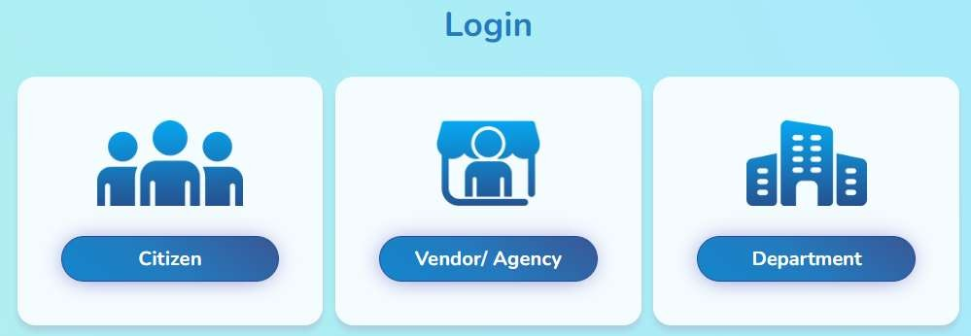
Figure 2.1: Login page – Choose Citizen, Vendor/Agency, or Department
The login page presents three user type options:
Login Type | Who Uses It | Description
Citizen | Public users | Access forms open to citizens for social audit feedback
Vendor/Agency | Agency staff | Agency-specific login for vendor-related functions
Department | All government staff | Used by Super Admin, Dept Admin, Nodal Officer, RO, and Inspector

📌 Note: For PM Poshan Social Audit training, all government users (Admin, Nodal, Inspector) use the Department login.

2.3 Super Admin Dashboard
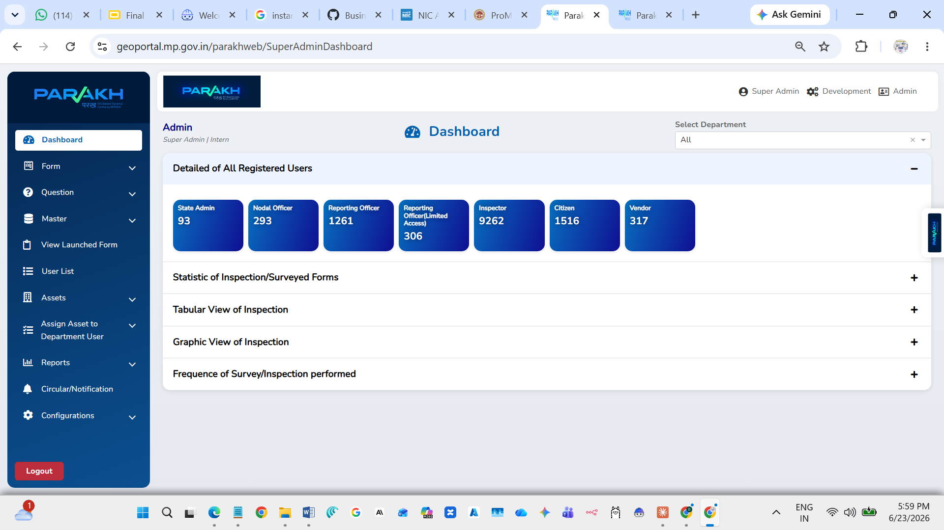
Figure 2.2: Super Admin Dashboard showing registered user statistics
After login, the Dashboard displays real-time statistics across all registered users:
User Type | Count (Sample)
State Admin | 93
Nodal Officer | 293
Reporting Officer | 1,261
Inspector | 9,262
Citizen | 1,516
Vendor | 317

3. User Management

3.1 Step 1: Super Admin Creates Department Admin
Login with Super Admin credentials (e.g., pmposhanadmin) and navigate to:
- Sidebar → Master → Create User
- Department Name: PNRD-PMPOSHAN
- Fill: First Name, Last Name, Mobile Number, Email, Designation
- User Type/Role: Select Department Admin
- Enter unique Username → Click Add User

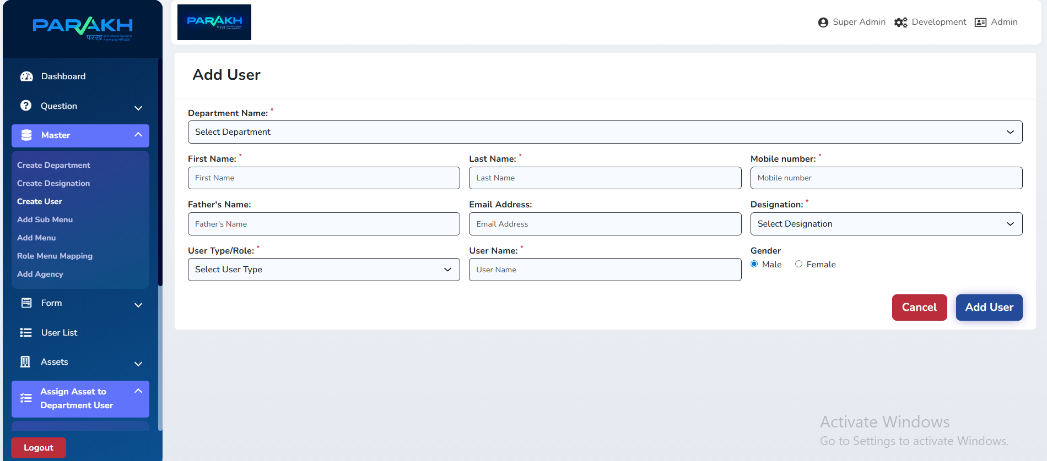
Figure 3.1: Add User form – Super Admin creates Department Admin

3.2 Step 2: Department Admin Creates Nodal Officer
Department Admin logs in and creates Nodal Officers at the district level:
- Navigate to: Master → Create User
- User Type/Role: Nodal Officer
- Set Access Area: assign the relevant district (e.g., Bhopal)
- Save – Nodal Officer can now log in

3.3 Step 3: Nodal Officer Creates Reporting Officer
Inside the Nodal Officer's account, create Reporting Officers for each block:
- User Type/Role: Reporting Officer
- Assign block/tehsil-level access area

3.4 Step 4: Create Inspector
The Inspector can be created by Nodal Officer or Reporting Officer. Best practice:
📌 Note: Always create Inspectors under the Reporting Officer (RO) for accurate district-block hierarchy.

- User Type/Role: Inspector
- Assign Reporting Officer from dropdown (parent in hierarchy)
- Inspector credentials are used for the mobile app login

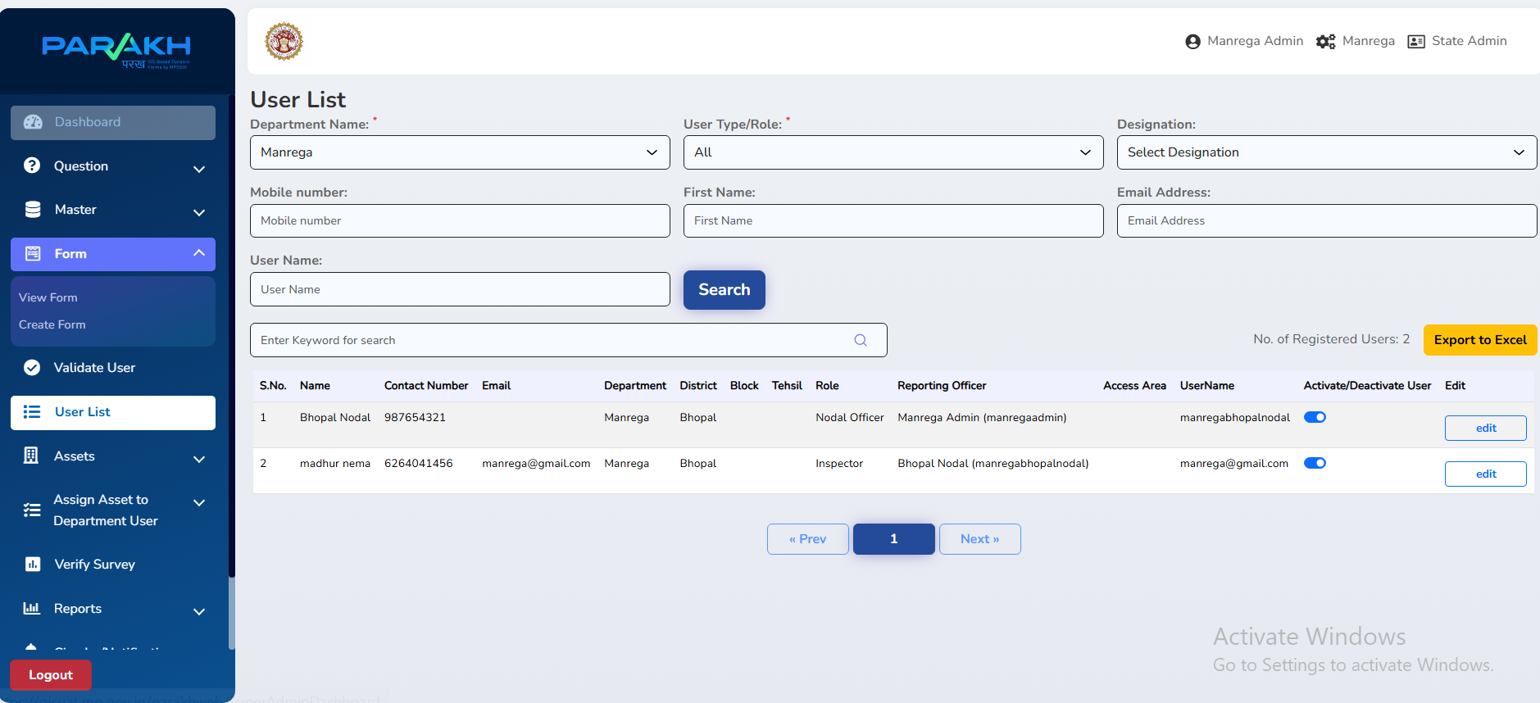
Figure 3.2: User List – showing created Nodal Officer and Inspector

3.5 Validate User
After Inspector self-registers or is created, the Nodal Officer must validate the user:
- Sidebar → Validate User → Search by name/mobile
- Review details → Click Approve
- Approved Inspectors can now log into the mobile app

4. School List & Assignment

4.1 Viewing the School List
Admins can view all schools enrolled under PM Poshan for a specific district and block:
- Sidebar → Schools → School List
- Select Department: PNRD-PMPOSHAN
- Select District (e.g., Balaghat) and Block (e.g., Katangi)
- View Non-Nominated and Nominated school counts
- Use keyword search to find specific schools

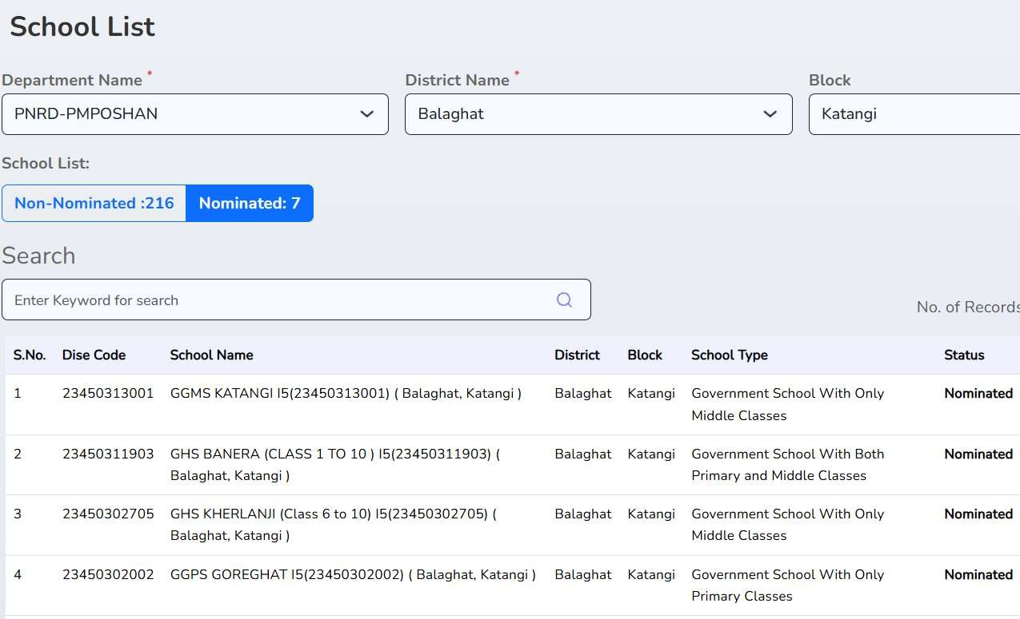
Figure 4.1: School List showing Nominated vs Non-Nominated schools in Balaghat

4.2 Nominating Schools for Social Audit
Before assignment, schools must be nominated for social audit:
- From the School List, click on a non-nominated school
- Review school details (DISE Code, School Name, Type, Location)
- Click Nominate to mark it for social audit
- School status changes to 'Nominated'

4.3 Assigning Schools to Inspectors
Once nominated, schools are assigned to specific Inspectors for audit:
- Sidebar → Assign Schools For Social Audit
- Select Department and District
- From the nominated schools list, select the school
- Choose Inspector from the dropdown
- Click Assign – Inspector now sees this school in their mobile app

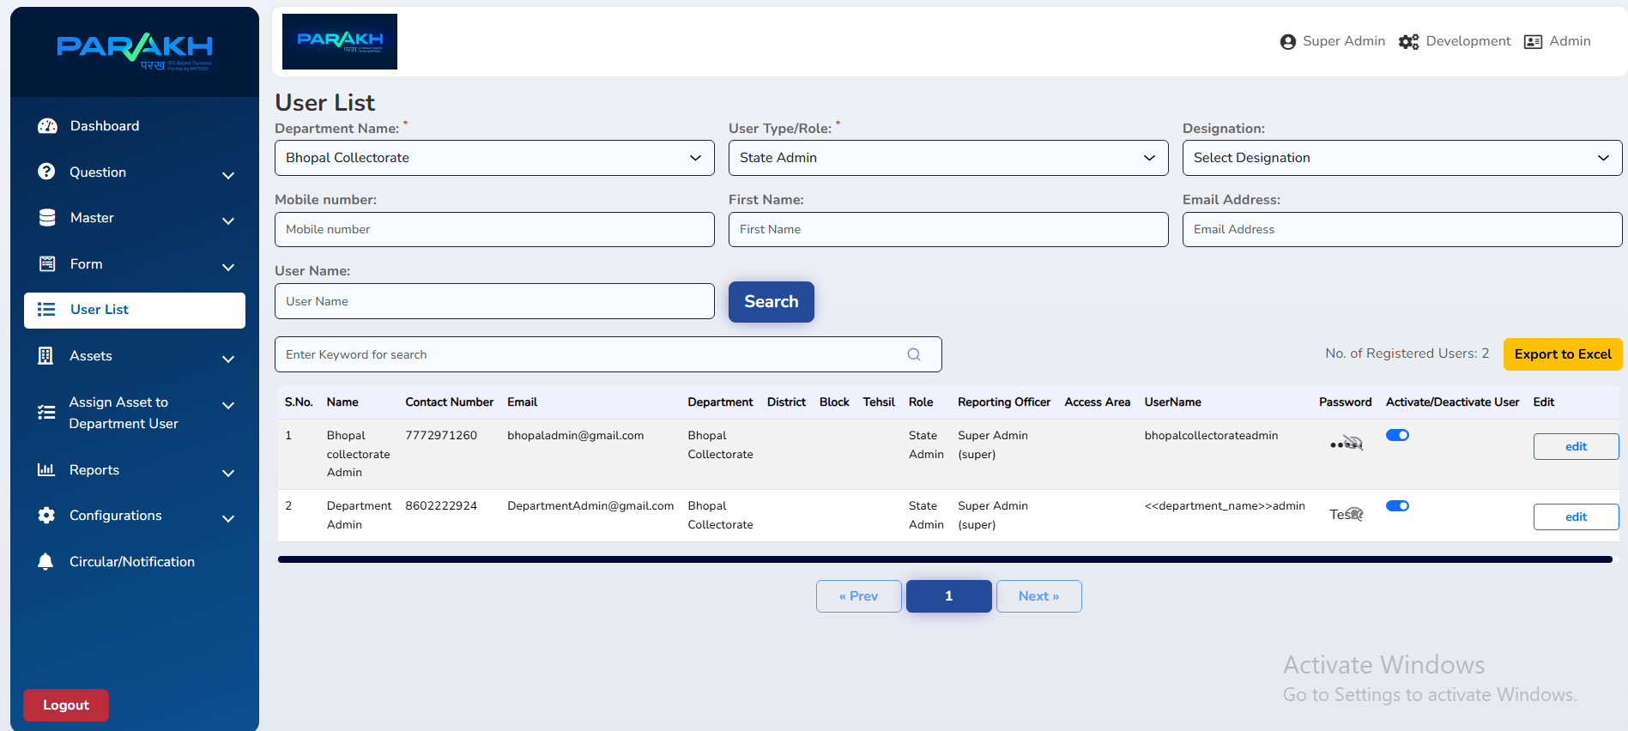
Figure 4.2: Assign School for Social Audit – Web Portal

5. Dynamic Form Creation

5.1 Form Types
Navigate to: Sidebar → Form → Create Form to access the form creation module.

Form Type | Purpose | Used By
Data Collection / Survey Form | Daily/frequent data collection by Inspectors for assets | Inspectors
Department General Form | Department-level inputs and reporting | Dept Admin, Nodal Officer
Citizen General Form | Open forms accessible to all citizens | Citizens
Inspection Form | One-time linked forms for school/asset audits | Inspectors, Dept Users

5.2 Creating a Form – Step by Step

Step 1: Login as Admin and Navigate
- Login with Admin Credentials (e.g., pmposhanadmin)
- Go to Modules → Department General Form / Inspection → Select Form Create (फॉर्म क्रिएट करना)

Step 2: Choose Form Type
Select from the four form types based on the audit requirement. For PM Poshan, use Inspection Form.

Step 3: Define Questions
- Click Create Question
- Add Main Question: e.g., 'Is the work completed on time?'
- Add Sub Questions: e.g., 'If No, specify reason' – linked to parent question
- Set question type: Text, Number, Date, Yes/No, Photo, GPS Location

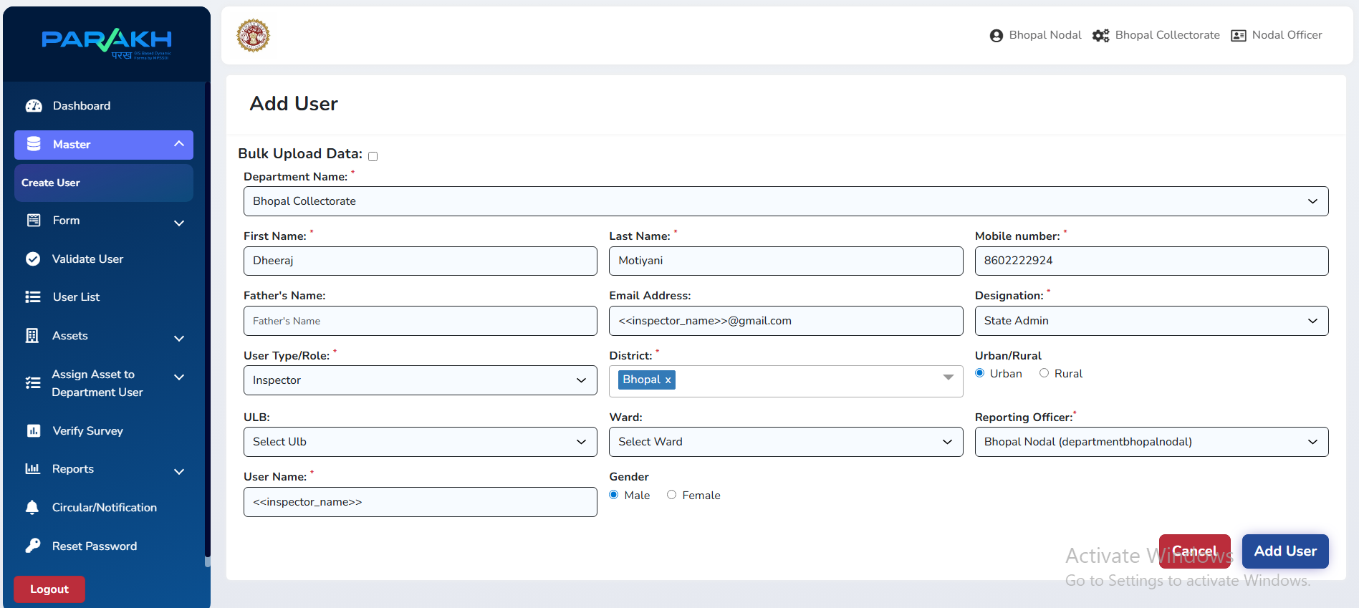
Figure 5.1: Create Question screen in Form Builder
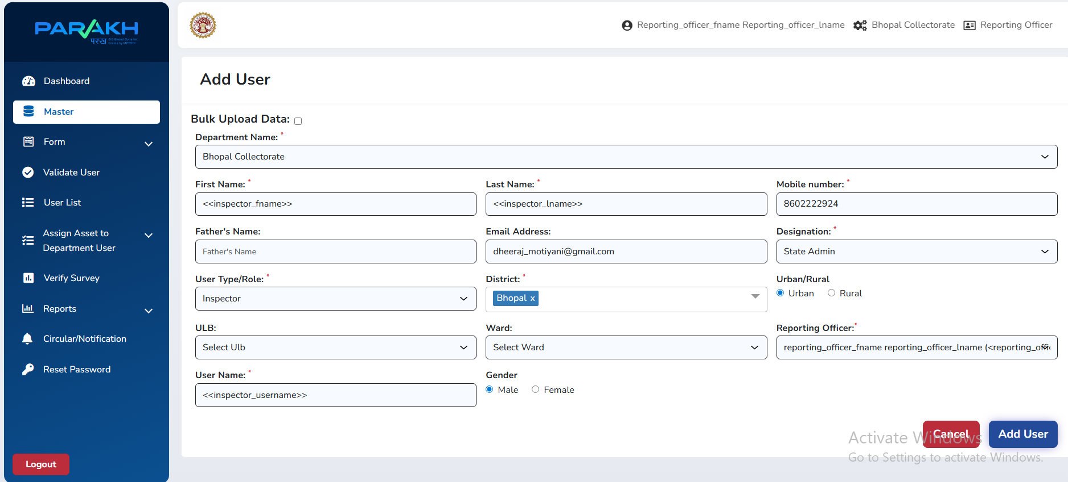
Figure 5.2: Question list view with main and sub-questions

Step 4: Set Form Visibility
- Define who can access and fill the form:
- Department Users (Dept Admin, Nodal, RO)
- Inspectors – field data collection
- Citizens – public participation forms

Step 5: Asset Creation & Assignment
- Create Assets (e.g., schools) in the system via Assets module
- Assign each asset to the relevant Department User or Inspector
- The Inspection Form is then linked to the assigned asset

6. Mobile App – District GIS Parakh

6.1 App Overview
The District GIS Parakh mobile app (Android) is used by Inspectors in the field to conduct social audits. It supports photo capture, GPS tagging, offline form saving, and direct submission.

6.2 Getting Started
Step | Action | Details
1 | Download & Install | Install from Google Play Store or APK link shared by Dept Admin
2 | Open App | District GIS Parakh app opens with district list
3 | Login | Use Department credentials assigned by RO/Nodal Officer
4 | Select District | Tap your assigned district from the list (e.g., Bhopal, Balaghat)

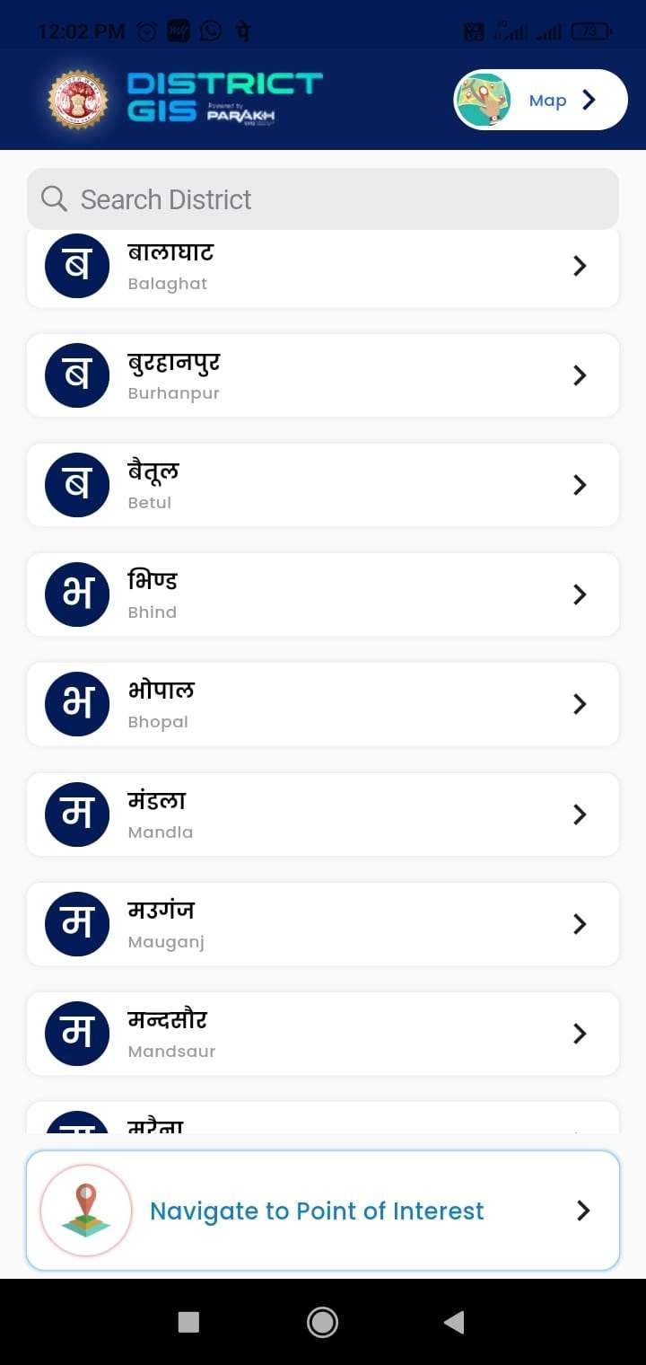
Figure 6.1: Mobile App – District selection screen

6.3 App Navigation Menu
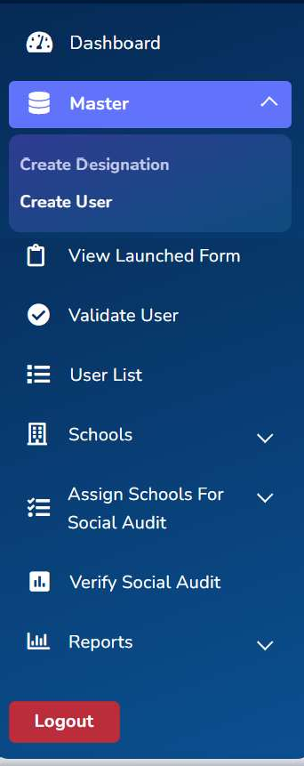
Figure 6.2: Mobile App – Main navigation menu
The navigation menu provides access to:
Menu Item | Description
Dashboard | Overview of assigned schools and pending audits
Master → Create Designation | Setup designations (admin function)
Master → Create User | Create sub-users if permitted
View Launched Form | See all active forms available for filling
Validate User | Approve pending user registrations
User List | View all users in hierarchy
Schools | View schools assigned for social audit
Assign Schools For Social Audit | View and manage school assignments
Verify Social Audit | Review and verify submitted audit forms
Reports | View statistical reports and summaries

6.4 Conducting a Social Audit (Inspector Steps)
- Tap Schools → Assign Schools For Social Audit
- Select your assigned school (nominated by admin)
- Tap the school to open the PM Poshan inspection form
- Fill all required sections: beneficiary count, food quality, infrastructure
- Capture photos of cooking area, food, stock register as required
- GPS location is auto-captured when form is opened
- Save draft if connectivity is poor; submit when online
- Submission confirmed with timestamp and reference number

6.5 Mobile App Screenshots
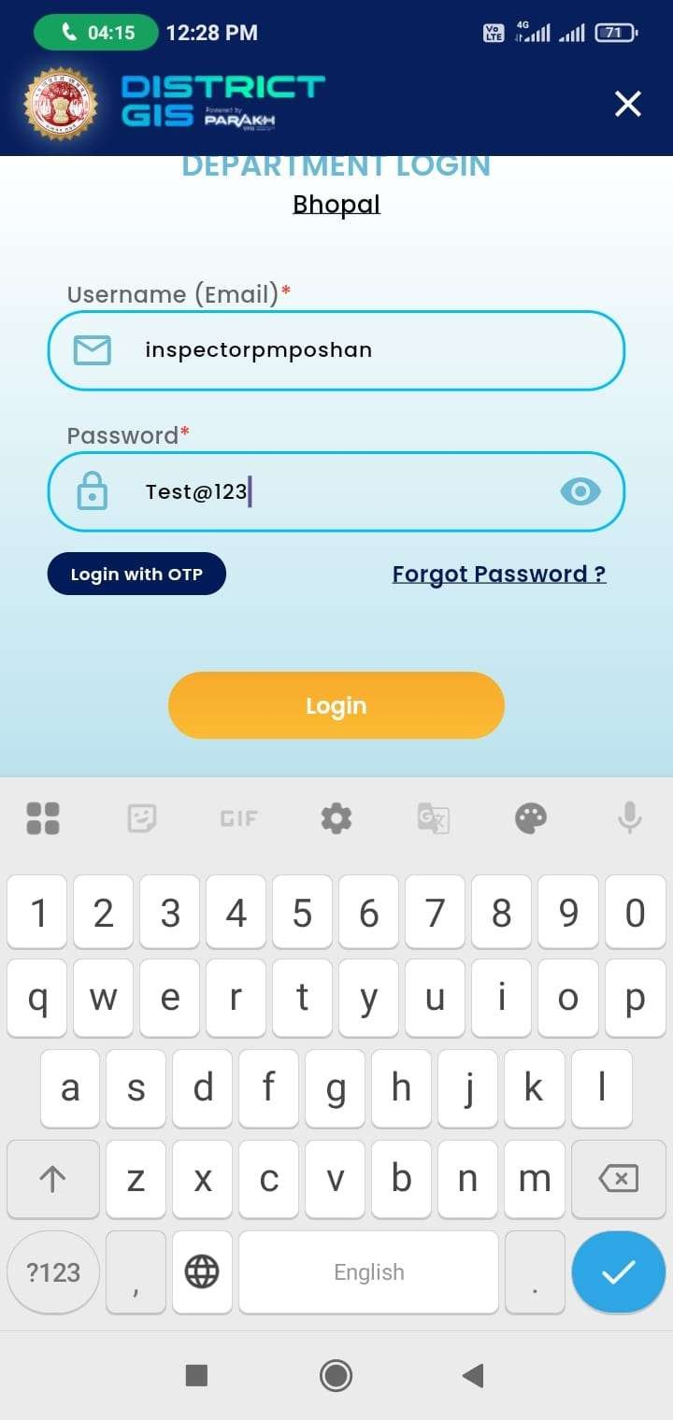
Figure 6.3: App Login Screen
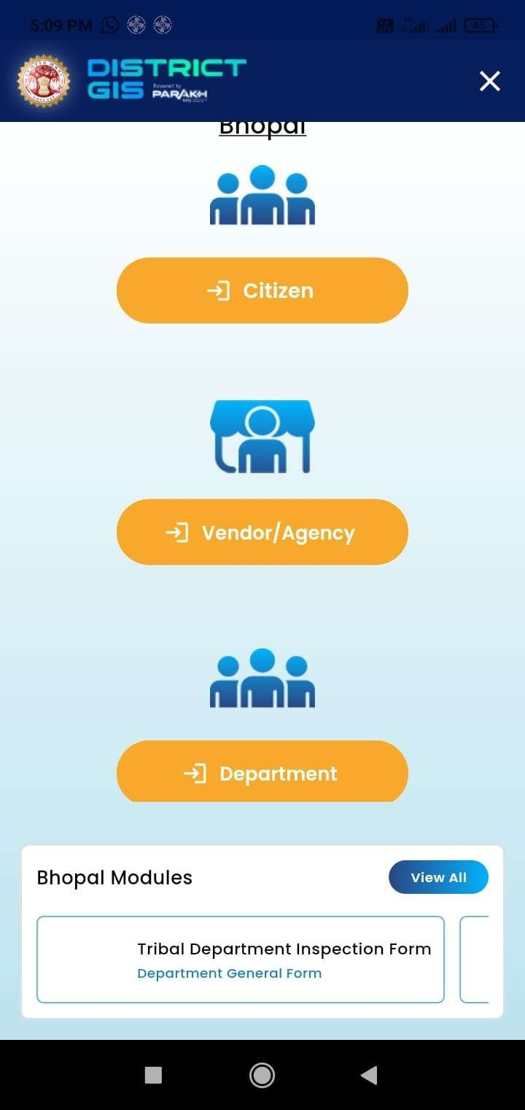
Figure 6.4: School Selection
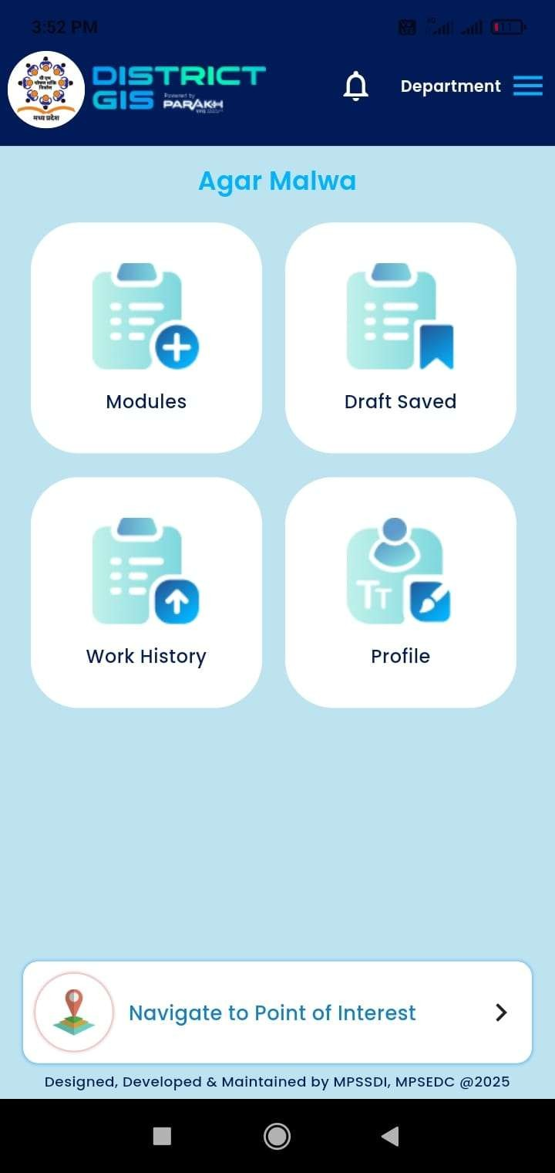
Figure 6.5: Form Filling – Section 1
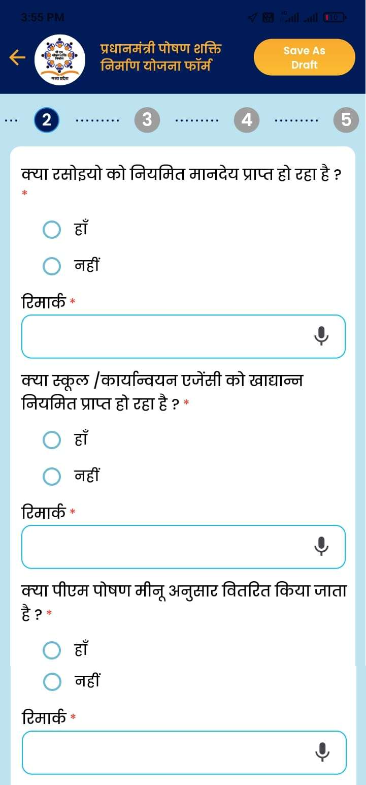
Figure 6.6: Form Submission Screen

7. Verification & Reports

7.1 Verifying Submitted Audits
Nodal Officers and Reporting Officers verify the audit data submitted by Inspectors via the web portal:
- Login to web portal → Sidebar → Verify Survey / Verify Social Audit
- Filter by Department, District, Block, School Name
- Click on a submitted form to review all answers, photos, and GPS data
- Approve the audit or send back with remarks for correction

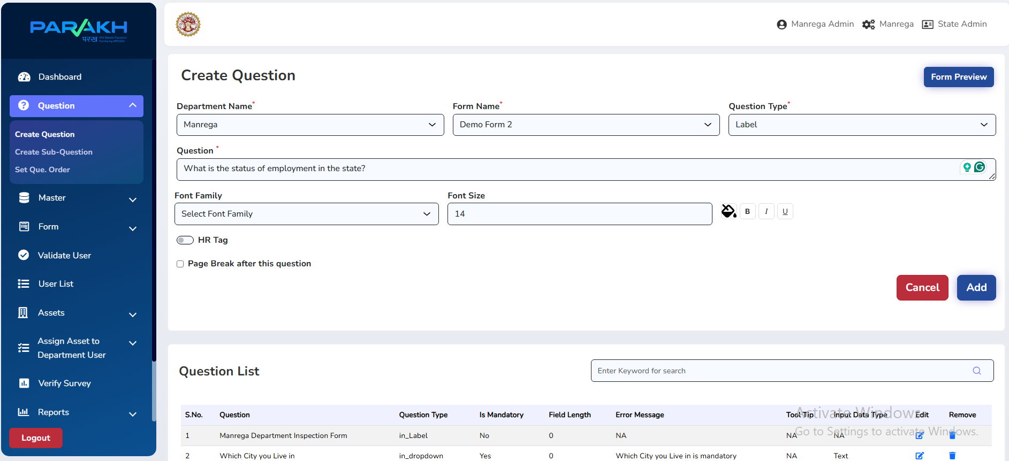
Figure 7.1: Verify Survey screen – Web Portal

7.2 Reports & Data Export
Comprehensive reports are available in the web portal for analysis:
- Sidebar → Reports → Select report type
- Filter by date range, district, block, school
- Graphic View: bar charts and trend analysis
- Tabular View: detailed row-by-row audit data
- Export to Excel for further analysis

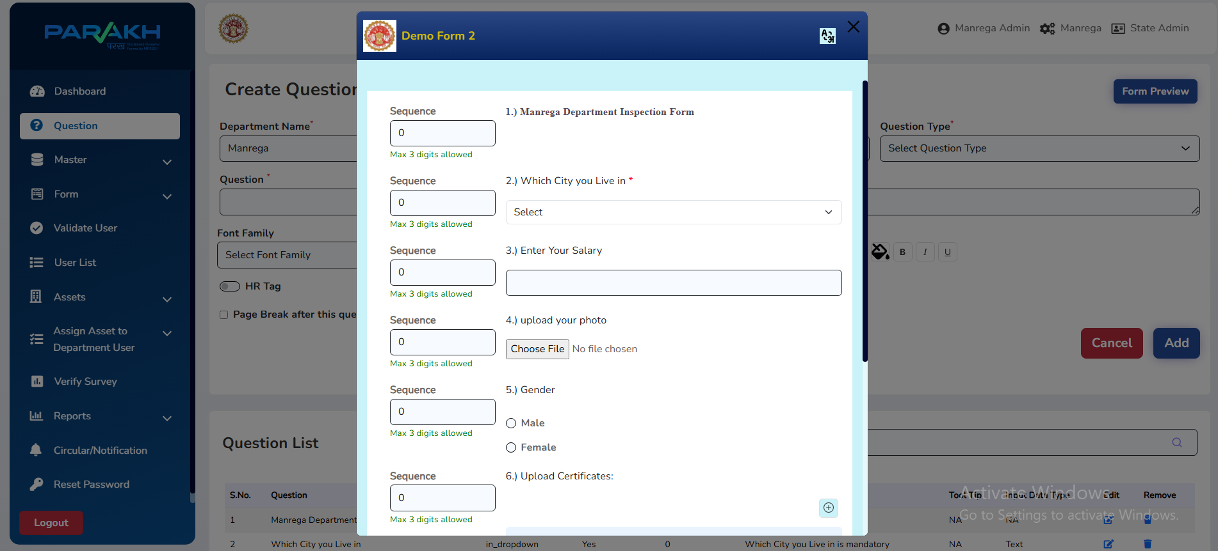
Figure 7.2: Reports section – Tabular and graphical views

Report Type | Description | Who Uses It
Submission Summary | Total audits submitted vs pending by school/block | Nodal Officer, RO
Verified vs Pending | Approved audits vs awaiting verification | Dept Admin, Nodal
Inspector Performance | Number of audits completed per Inspector | Dept Admin
Graphical Dashboard | Visual charts of audit completion rates | All Admins
Excel Export | Full data export for offline analysis | All Admins

8. Quick Reference Guide

8.1 Web Portal URL
https://geoportal.mp.gov.in/parakhweb/

8.2 Common Tasks – Quick Reference
Task | Navigation Path | Role Required
Create Dept Admin | Master → Create User → User Type: Dept Admin | Super Admin
Create Nodal Officer | Master → Create User → User Type: Nodal Officer | Dept Admin
Create Inspector | Master → Create User → User Type: Inspector | Nodal / RO
Validate Inspector | Validate User → Search → Approve | Nodal Officer
View School List | Schools → School List → Select Dept/District | Dept Admin, Nodal
Nominate School | School List → Click school → Nominate | Dept Admin
Assign School to Inspector | Assign Schools For Social Audit → Select → Assign | Dept Admin, Nodal
Create Form | Form → Create Form → Select type → Add Questions | Dept Admin
Inspector: Submit Audit | Mobile App → Schools → Select school → Fill form → Submit | Inspector
Verify Audit | Verify Survey → Select school → Review → Approve | Nodal / RO
Export Report | Reports → Select type → Export to Excel | All Admins

8.3 Support Contact
Contact | Details
Organisation | MPSeDC – Madhya Pradesh State Electronics Development Corporation
Address | State IT Center, 47-A Arera Hills, Bhopal, MP – 462011
Phone | +91-755-2518300
Fax | +91-755-2579824
Website | www.mpsedc.mp.gov.in
Web Portal | https://geoportal.mp.gov.in/parakhweb/

धन्यवाद | Thank You
Government of Madhya Pradesh | MPSeDC | District GIS Parakh

